8 SEMESTER ONE
Papers written by Australian Maths Software

YEAR 12
MATHEMATICS SPECIALIST
REVISION 2
UNIT 3
2016
Section Two
(Calculator–assumed)

Name: _________________________________

Teacher: ________________________________

TIME ALLOWED FOR THIS SECTION

Reading time before commencing work: 10 minutes
Working time for section: 100 minutes

MATERIAL REQUIRED / RECOMMENDED FOR THIS SECTION

To be provided by the candidate
Standard items: pens, pencils, pencil sharpener, highlighter, eraser, ruler.
Special items: drawing instruments, templates, notes on up to two unfolded sheet of A4 paper, and up to three calculators approved for use in the WACE examinations.

IMPORTANT NOTE TO CANDIDATES
No other items may be taken into the examination room. It is your responsibility to ensure that you do not have any unauthorised notes or other items of a non–personal nature in the examination room. If you have any unauthorised material with you, hand it to the supervisor before reading any further.

To be provided by the supervisor
Question/answer booklet for Section Two.
Formula sheet retained from Section One.
Structure of this examination

 | Number of questions available | Number of questions to be answered | Working time (minutes) | Marks available | Percentage of exam
Section One  Calculator—free | 5 | 5 | 50 | 50 | 35
Section Two  Calculator—assumed | 11 | 11 | 100 | 100 | 65
Total marks |  |  |  | 150 | 100

Instructions to candidates

1. The rules for the conduct of this examination are detailed in the Information Handbook. Sitting this examination implies that you agree to abide by these rules.

2. Write your answer in the Question/Answer booklet.

3. You must be careful to confine your responses to the specific questions asked and to
follow any instructions that are specific to a particular question.

4. Spare pages are provided at the end of this booklet. If you need to use them, indicate in the original answer space where the answer is continued i.e. give the page number.

5. Show all your working clearly. Your working should be in sufficient detail to allow your answers to be checked readily and for marks to be awarded for reasoning. Incorrect answers given without supporting reasoning cannot be allocated any marks. For any question or part question worth more than two marks, valid working or justification is required to receive full marks. If you repeat an answer to any question, ensure that you cancel the answer you do not wish to have marked.

6. It is recommended that you do not use pencil, except in diagrams.

7. The Formula Sheet is not to be handed in with your Question/Answer booklet.

6. (6 marks)

Evaluate
(a) 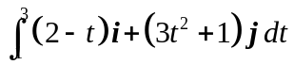 (3)

(b) 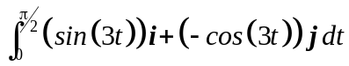 (3)

7. (26 marks)

(a) A moth is flying around in circles following the path 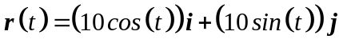.
(i) Convert the equation of the path to a Cartesian equation and sketch it on
the set of axes below. (3)

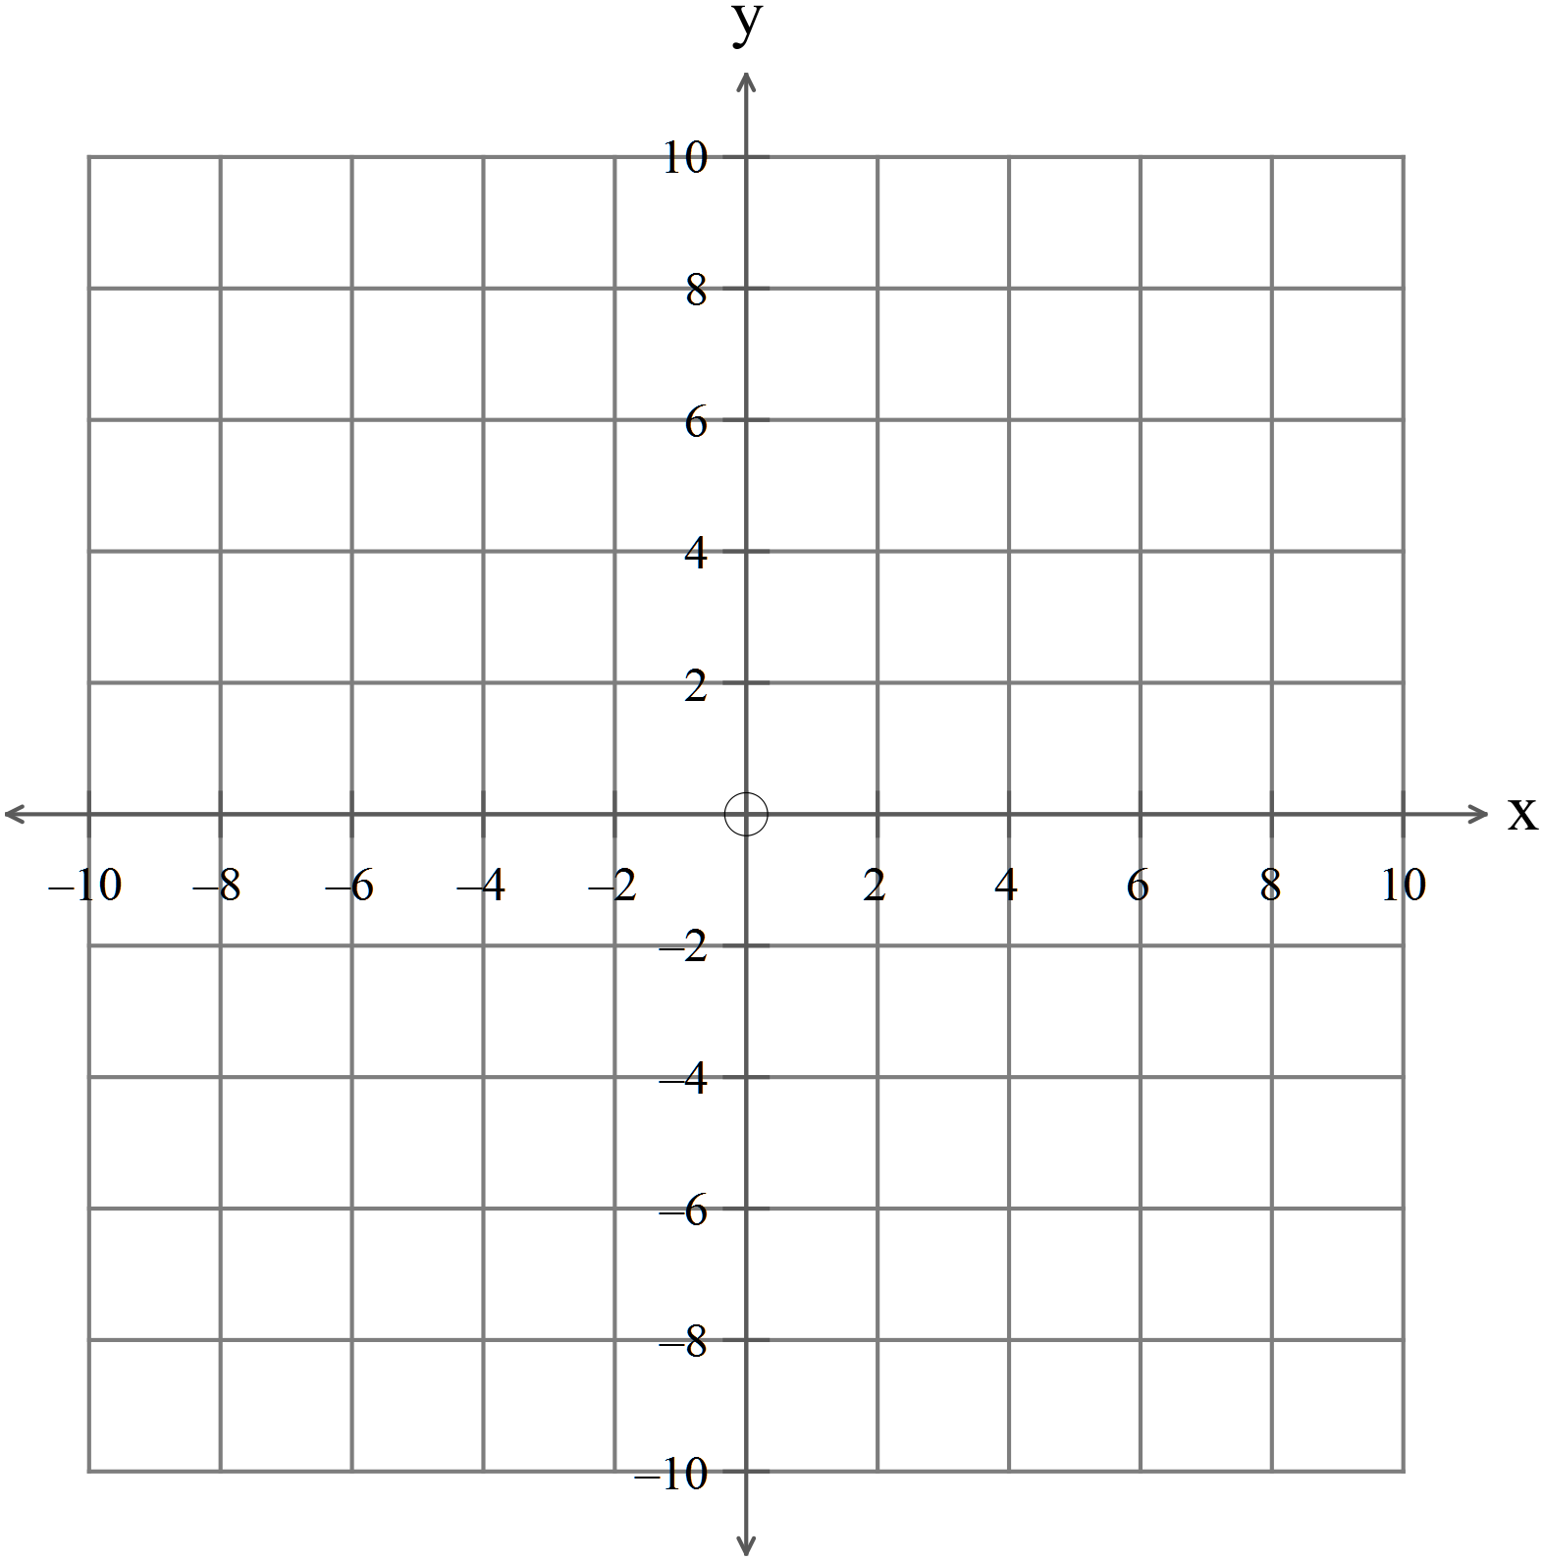
(ii) Prove that the position vector is at right angles to the velocity vector. (3)

(iii) Show that 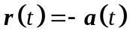 and explain why the acceleration is always
directed towards the centre of the motion. (3)

(iv) Sketch the acceleration and velocity vectors on the diagram at 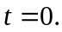 (4)

(v) Show that the speed of the moth is always constant. (3)

(b) The position vector of a particle at time is given by
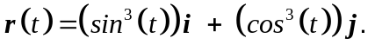
The relationship is graphed below:
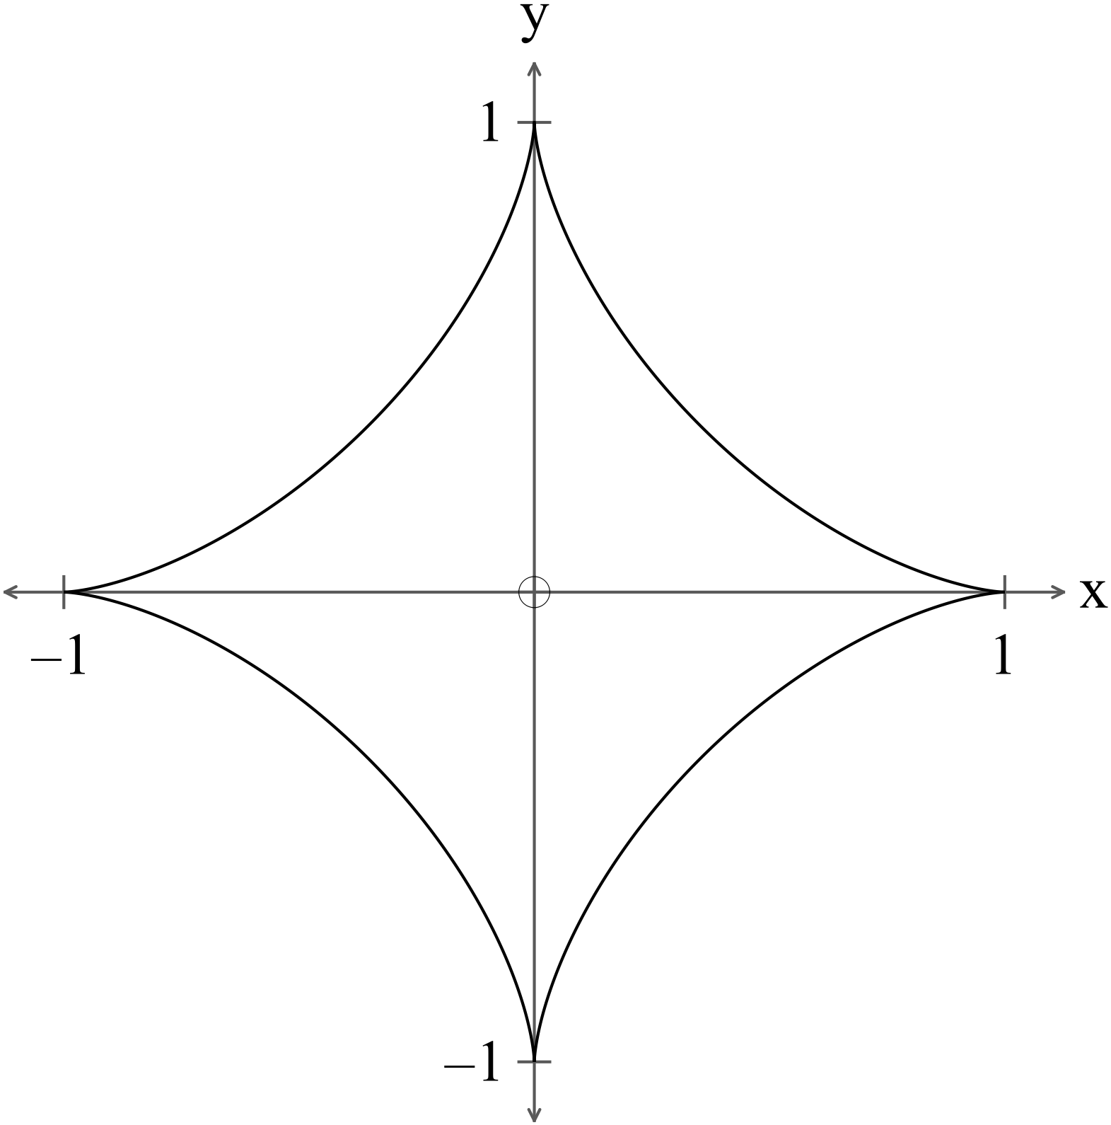
(i) Determine the position of the particle at  and indicate the direction of
travel of the particle on the diagram. (3)

(ii) Find the expression for the velocity of the particle. (3)

(iii) Sketch the velocity vector on the graph at 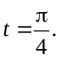 (2)

(iv) Determine the first time that 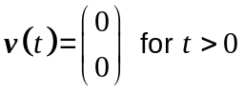. (3)

8. (3 marks)

ABCDEFG is a cube as shown in the diagram below.
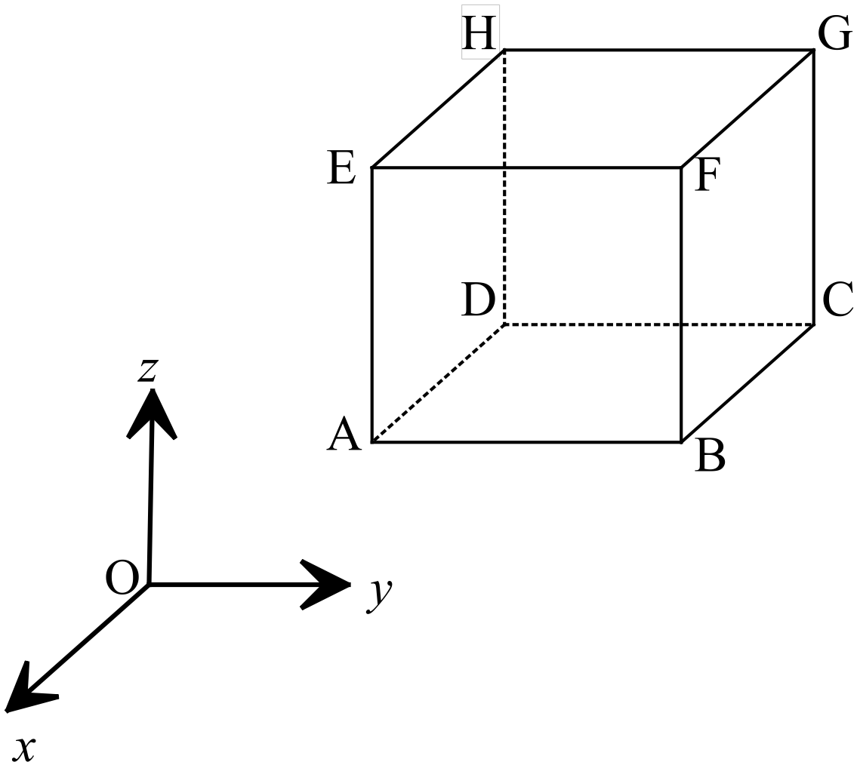

The position vectors of points 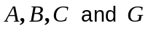 are 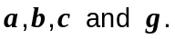
Determine the following in terms of the given position vectors

(a) 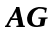 (2)

(b) 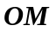 where  is the midpoint of 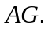 (1)

9. (13 marks)
(a) The diameter of a sphere is 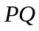 given 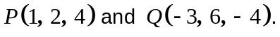
(i) Find the Cartesian equation of the sphere. (3)

(ii) Find the vector equation of the plane 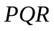given 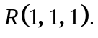 (3)

(iii) Find the vector normal to the plane . (1)

(b) A bird at 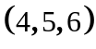 swooped down on a mouse at 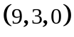 with a velocity of
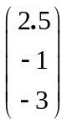.

(i) How long would the bird take to reach the mouse? (1)

After one second, the mouse is alerted by the bird’s shadow and runs for its
hole at 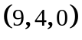 with a velocity of 1 metre per second.
(ii) How long does the mouse take to get to its hole? (1)

Instantaneously (i.e. after one second), the bird adjusts its velocity to 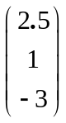.
(iii) What is the change in the bird’s speed? (2)

(iv) Does the bird catch the mouse? Explain. (2)

10. (12 marks)

(a) Find 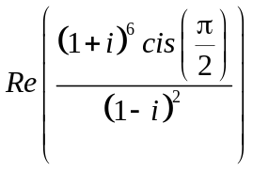. (3)

(b) Given 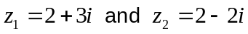 sketch 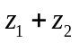 on the set of axes below. (2)
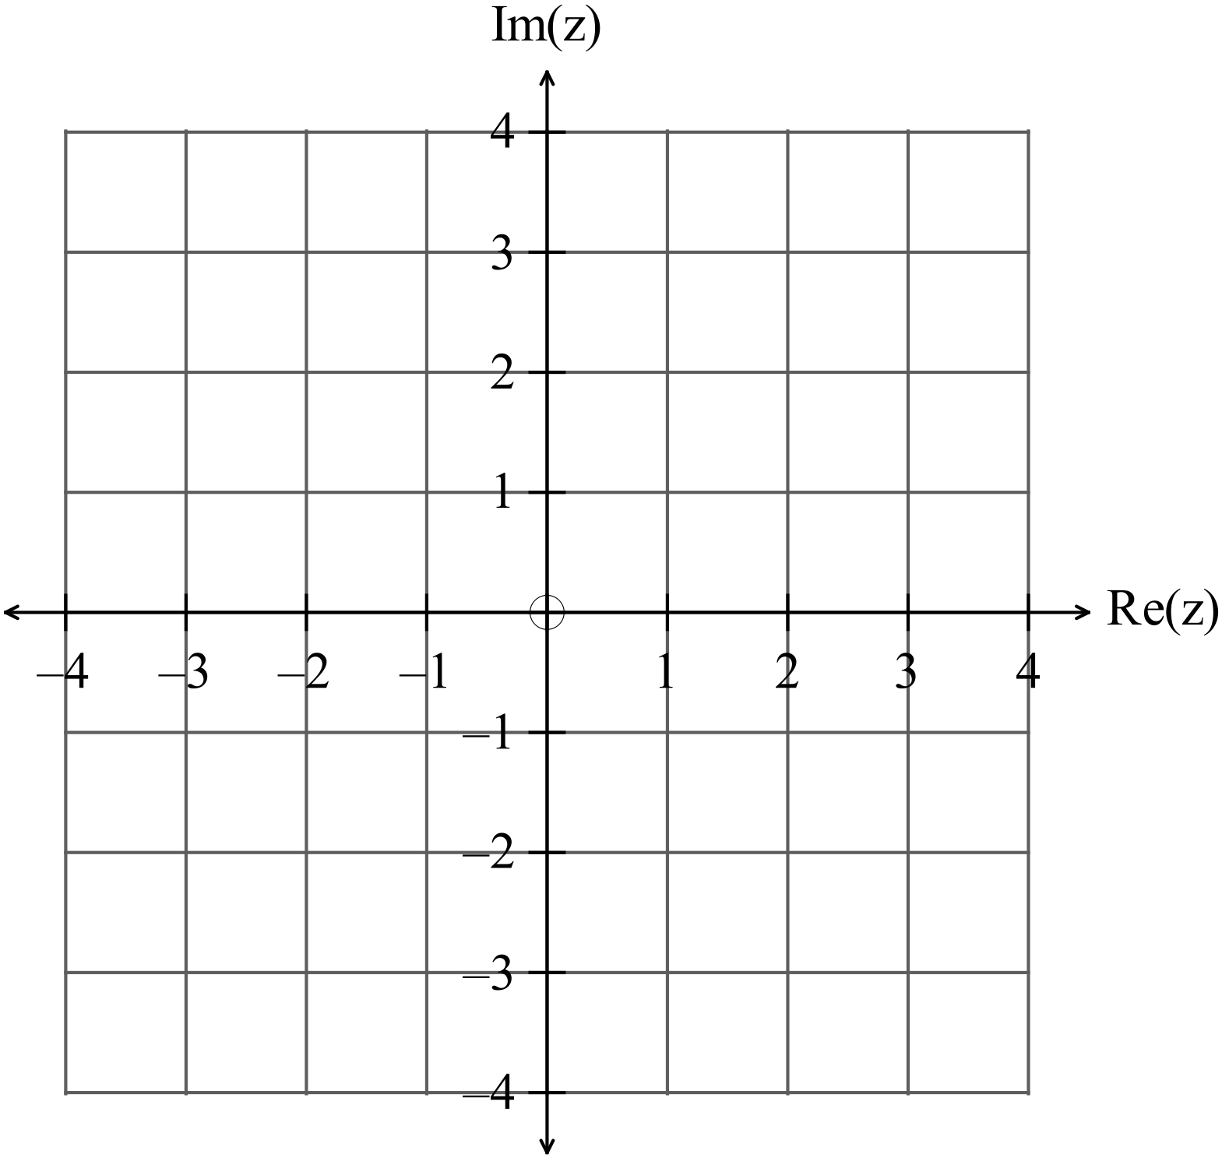
(c) Use an algebraic method to find the real numbers 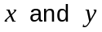such that
(i) 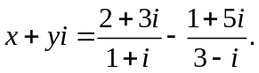 (6)

(ii) Find the real numbers such that 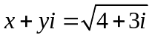 (1)

11. (6 marks)
Given the vectors 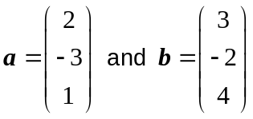
(a) Find the angle between the vectors. (2)

(b) Find the projection of 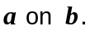 (2)

(c) Write down a vector 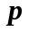 such that 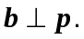 (2)

12. (17 marks)
(a) Given (4)
(b) Given the function 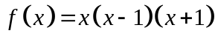graphed below
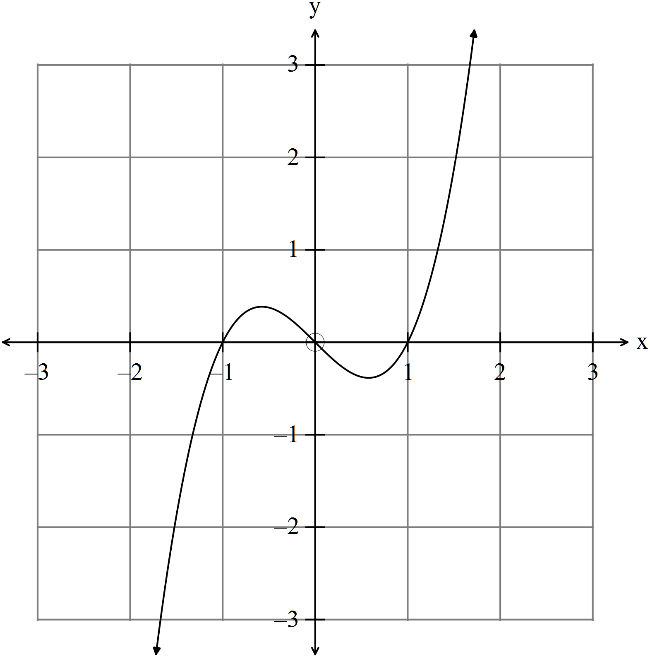
Determine the equation of the functions graphed below.
(i) (1)
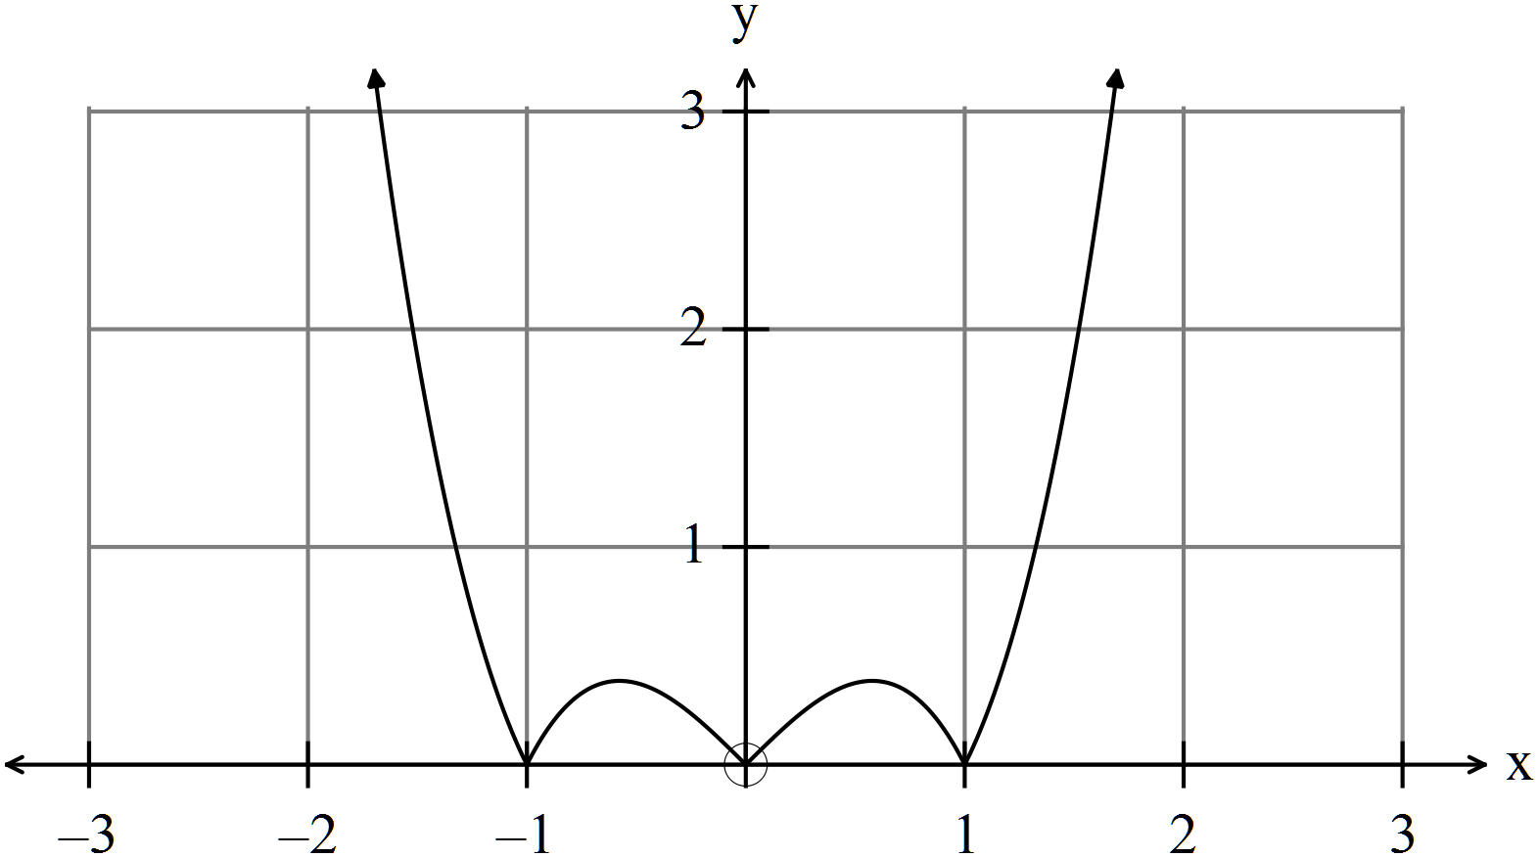

(ii) (2)
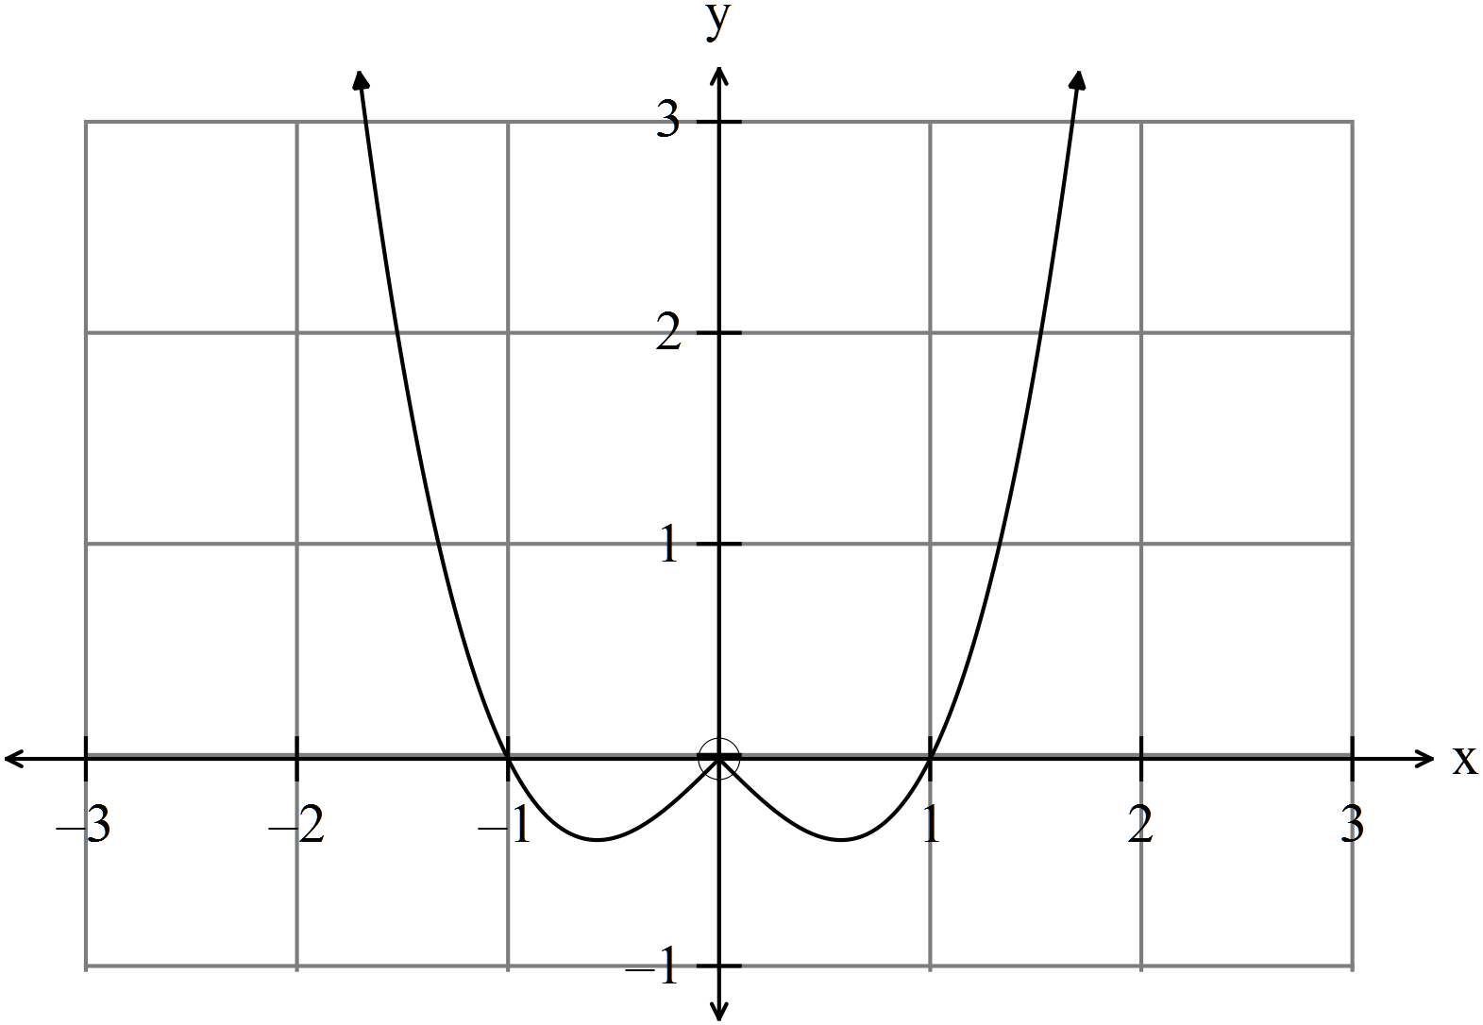

(iii) (3)
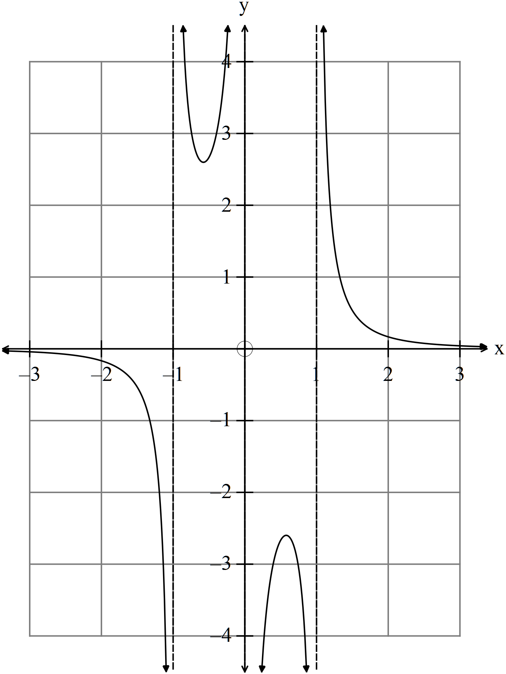
(c) If 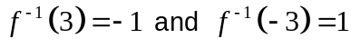 then
(i) find 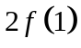. (1)

(ii) find 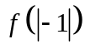. (1)

(iii) find 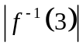. (1)

(iv) determine if the statement 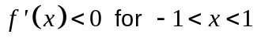 is true or false. (1)

(v) determine if the statement 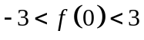 is true or false. (1)

(d) Given 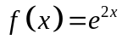 find
(i) 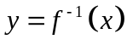. (1)

(ii) 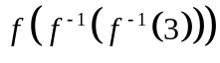. (1)

13. (4 marks)

(a) Given 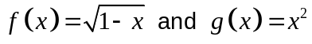 write down the domain and range of
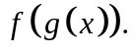 (2)

(b) (i) Given 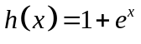, determine the equation of the inverse function
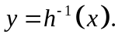 (1)

(ii) Determine 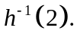 (1)

14. (4 marks)

Complete
(a) 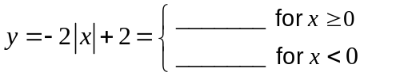 (1)

(b) 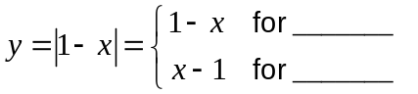 (1)

(c) Hence solve 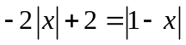 algebraically, showing all working. (2)
15. (3 marks)

The graph below has the equation 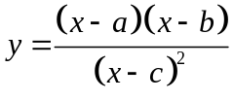.
Determine the values of 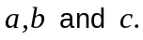 (3)

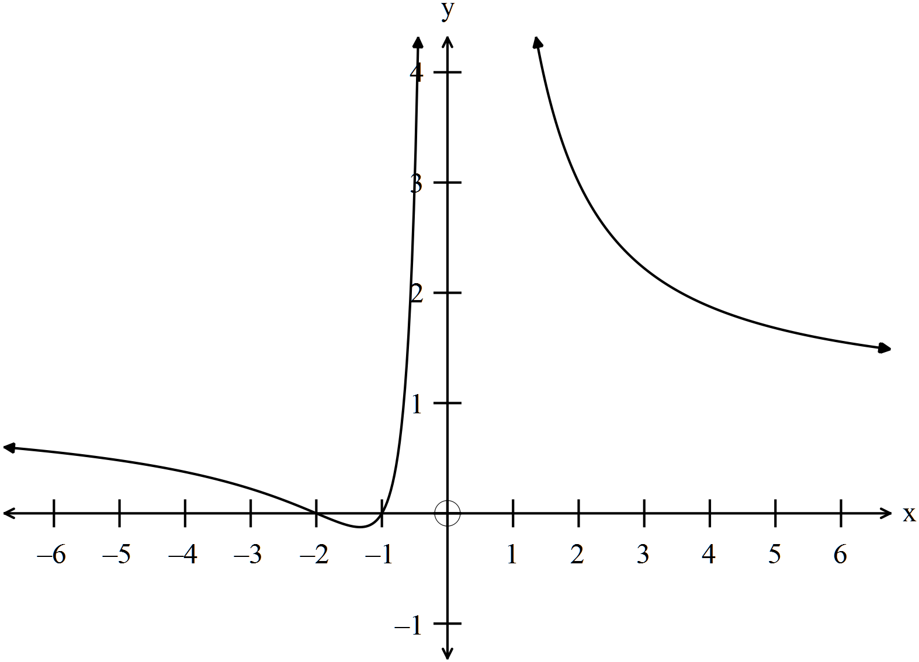

16. (5 marks)

Use de Moivre’s Theorem to prove that .
(5)

END OF SECTION TWO

